Flexible electrification in Brazil: an emerging strategy to mitigate renewable energy curtailment and reduce operational costs
João Pedro Vidotti de Cesaro^{a,b*}, Juan Antonio Labarta Reyes^{b}, Mauro Antonio da Silva Sá Ravagnaniª, Caliane Bastos Borba Costaª
ªUniversidade Estadual de Maringá, Programa de Pós-Graduação em Engenharia Química, Maringá-PR, Brasil
^{b}Universidad de Alicante, Departamento de Ingeniería Química & Instituto de Ingeniería de los Procesos Químicos, Alicante-C. Valenciana, España
*pg55952@uem.br
ABSTRACT

The increasing penetration of renewable energy sources in Brazil has led to significant curtailment levels, driven by the mismatch between variable generation and relatively inflexible demand. This work investigates the potential of flexible electrification as a strategy to mitigate curtailment and reduce operational costs. Publicly available data from Brazilian agencies were analyzed to quantify curtailment patterns, hydropower turbinable discharge, and electricity price dynamics in 2025. Results show substantial curtailment levels, reaching 37.2 TWh for wind and solar generation, with an additional 21.0 TWh associated with hydropower constraints. Electricity prices exhibit strong intra-day variability, with median spreads exceeding 150%, indicating favorable conditions for load shifting. These findings highlight the relevance of demand-side flexibility in Brazil and suggest that flexible electrification can play a key role in improving system efficiency and reducing costs.

Keywords: Curtailment, Flexible Electrification, Demand-side Flexibility, Brazil, Electricity Market
  - Background
The world is undergoing a fast-paced energy transition, in which traditional energy sources such as coal, diesel, and natural gas are being replaced by renewable sources, such as wind and solar photovoltaics (PV). This replacement comes with challenges as traditional energy sources are dispatchable, while renewables are mostly intermittent. In this context, a concerted effort is being made to electrify the economy and increase demand-side flexibility (Mellot et al., 2025).
Likewise, the Brazilian energy market is also undergoing fast changes, mainly fueled by the increase in PV distributed generation, leading to system power ramps of upwards of 10 GW h⁻¹ during the end of daylight hours and renewable energy curtailment of up to 16 GW (Silva et al., 2026). In the first semester of 2025, centralized PV and wind generation were cut by 20.1 and 12.7 %, respectively. These curtailment rates are much higher than those in other systems, such as California, Germany, China, Spain, and the UK, which range from 1.75 to 9.24 % (Vieira et al., 2026). Additionally, significant attention has been given to energy storage systems in the Brazilian electricity sector (ANEEL, 2025), which can provide demand-side flexibility. However, other forms of increasing demand-side flexibility remain underexplored.
Emerging thermal process configurations, such as heat pumps, flash-based systems, and recompression-assisted distillation, are being investigated for power-to-heat applications and low-temperature waste heat recovery. In proposed case studies, some configurations reduce annualized costs by more than 50% compared to conventional hot utility systems (Mekidiche et al., 2024). These strategies also show improved performance across life cycle assessment using ReCiPe metrics, including different damage categories such as fossil fuel depletion, ecosystem quality, human health, metal depletion, particulate matter formation, etc (Mekidiche et al., 2025).
The aim of this paper, therefore, is to draw attention to the issue of renewable energy curtailment in Brazil and to discuss the potential of demand-side flexibility to lower curtailment levels, while also reducing energy costs.
  - Methods
The data used in this paper are available in public databases (CCEE, 2026; ONS, 2025). Curtailment and generation were aggregated by summing the output of individual plants, and hourly profiles were obtained by averaging the data for each hour, rather than using the original half-hourly resolution. Curtailment is calculated by the difference between actual generation for each plant and its reference production at that hour of the day, as defined by the operator of the national system (ONS).
  - Literature review
Some of the strategies used by countries for electrification are the creation of public policies that encourage, and sometimes directly subsidize, technologies that reduce carbon emissions. Among these are the adoption of electric vehicles (EVs), heat pumps, electrolyzers, and new industrial loads (Mellot et al., 2025). On the other hand, flexibility policies require the previous adoption of smart meters (Mellot et al., 2025). Brazil lags behind this front, requiring power companies to install smart meters in 2 % of their clients per year after 2026 (MME, 2025). After clients have smart meters, flexibility may be encouraged through time-of-use or real-time pricing mechanisms, or controlled through direct load control (Mellot et al., 2025).
The adoption of electrified technologies to replace heat and transport increases overall electricity demand. However, when implemented in tandem with energy demand reduction and system flexibility policies, these were shown to lead to from 43 % (smart charging implemented) up to 69 % (using vehicle-to-grid energy) reductions in evening transformer loading (Mellot et al., 2025).
Göke et al. (2023) estimated that flexible demand from EV charging, district heating, process heat, and electrolyzers could reduce residual peak loads from 178.2 to 88.5 GW and excess generation from 205.5 to 41.9 TWh. Although the contribution of flexible space and process heating was estimated at only 2.0 TWh, the authors assumed that heat demand must be fully satisfied at each time step and did not consider partial heating combined with thermal storage, suggesting additional untapped potential. Power-to-X (P2X) technologies have also been studied to increase demand-side flexibility (Onodera et al., 2023). These technologies consist of the conversion of electricity into sustainable energy carriers such as hydrogen and synthetic hydrocarbons. The case study, set in Japan, demonstrates that flexible P2X could reduce curtailment by more than 80% and overall system costs by 35%.
Knorr et al. (2025) reviewed process heat electrification and flexibility, noting that although flexibility is widely recognized as crucial, research in this area remains limited. Their analysis shows that only 29% of the reviewed studies explicitly address flexibility. The authors also highlight the need for further work on different modelling approaches and region-specific analyses to support the transition of industrial heat systems. In particular, load shifting and thermal storage are identified as key technologies enabling industries to adapt their energy demand to the fluctuating availability of renewable energy.
Cegla et al. (2023) argue that flexibility in the chemical industry can be achieved by designing processes with capacities above nominal levels, albeit at the expense of higher capital costs. They also highlight a trend toward small-scale, modular processes, which can better accommodate transient operation due to their faster dynamics.
Linear formulations for heat storage that do not account for start-up and shut-down costs have recently been proposed (Buonomano et al., 2026). The model optimizes one year of operation using real-time electricity prices. The authors conclude that thermal storage can increase heat pump coefficients of performance by up to 15%, reduce CO₂ emissions by up to 12%, and decrease electricity costs by up to 30% compared to a heat-pump-only system. Although the model itself was limited, as discussed by the authors, these results highlight the potential of thermal storage to improve heat pump performance and operational flexibility in high renewable penetration systems.
  - Results and discussion
As discussed in the literature review, flexible electrification is an emerging approach to reducing both renewable energy curtailment and operational costs. This topic is particularly relevant in Brazil, given the high levels of curtailment and the growing need for flexibility associated with increasing renewable penetration. Figure 1 illustrates hourly curtailment in Brazil in 2025. Curtailment of PV and wind generation is classified into three categories: unavailability (not shown), lack of demand (a), and grid reliability constraints (b). Unavailability refers to curtailment caused by factors external to plant operation, such as equipment failures. It is not included in the analysis due to its stochastic nature and limited potential for mitigation.

Figure 1. Hourly energy demand (a) and grid reliability (b) curtailment in Brazil in 2025.
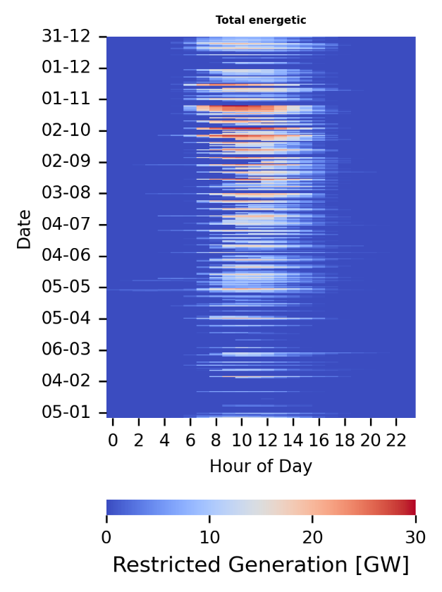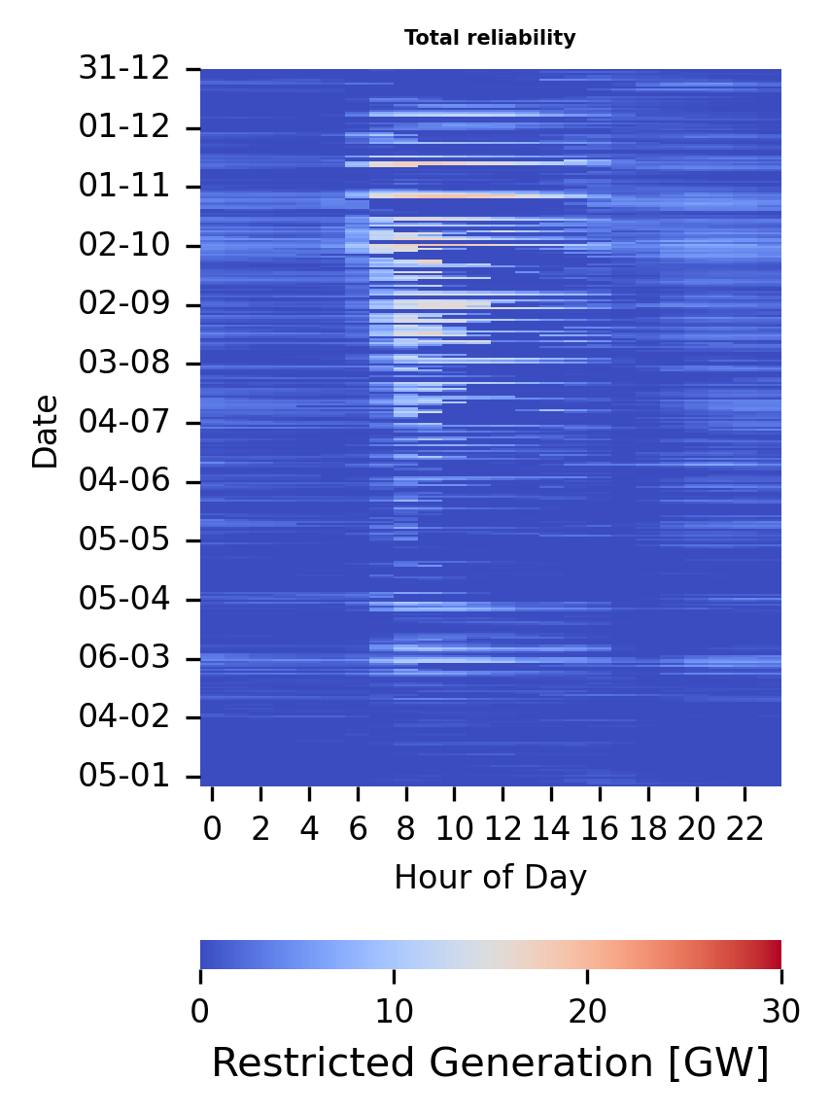
(b)
(a)
As seen in Figure 1, energy demand curtailment is more prone to happen during daylight hours, due to the increased PV production. On the other hand, grid reliability curtailment is more distributed with an increased rate from August to October, during the Brazilian windy season. The average curtailment in 2025 was 4.25 GW (37.2 TWh total), or about 20.7% of all centralized wind and PV generations (ONS, 2026). For comparison, the Brazilian monthly energy consumption ranged from 45.1 to 49.2 TWh in the same year (EPE, 2026).
Figure 2. Hourly hydropower turbinable discharge in Brazil in 2025.
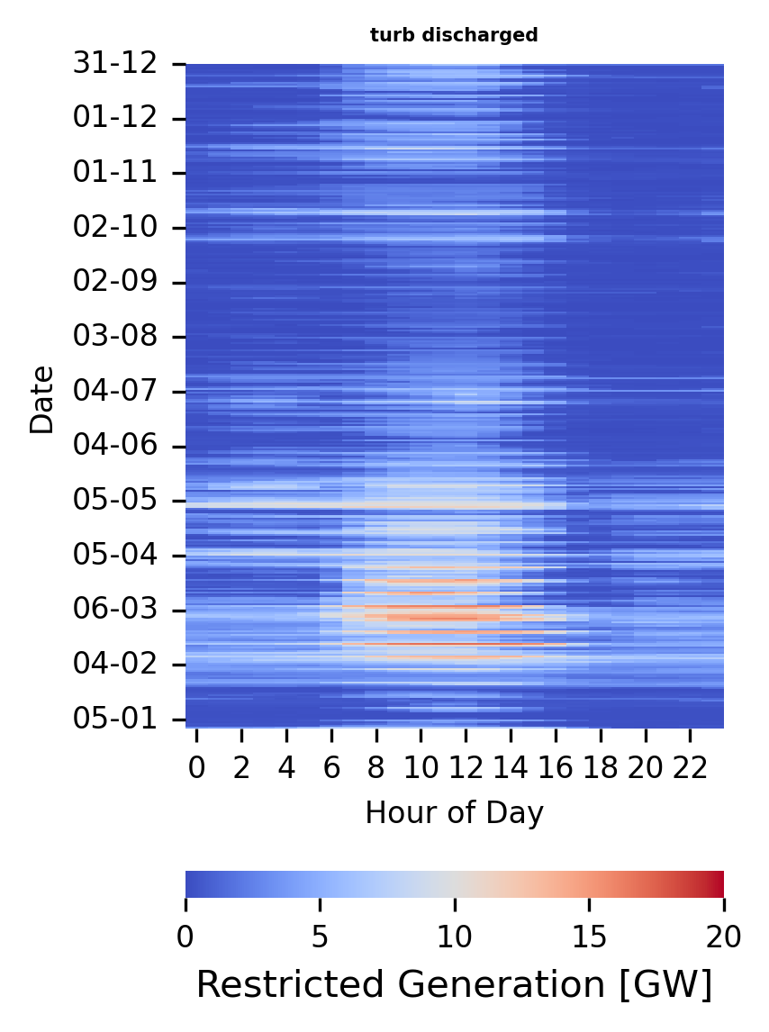
Figure 2 displays the hourly hydropower turbinable discharge in 2025. This type of curtailment is more prevalent during the first months of the year, corresponding to the Brazilian rainy season. This behavior is expected, as the North subsystem has significant run-of-river capacity that operates predominantly during these months. However, in 2025, significant turbinable discharge was also observed during the dry season. This can be attributed to PV overproduction during daylight hours, which forces hydropower plants to operate at their minimum river flow constraints. This additional effect accounts for approximately 21.0 TWh of curtailment.
Figure 3 presents the average electricity prices of the Price for Settlement of Differences (PLD) for 2025. Some outlier values in the range of 500-1100 BRL/MWh are observed; however, the color scale is limited to 0-500 BRL/MWh to improve visualization clarity. The PLD in 2025 exhibits a dual behavior associated with renewable energy curtailment. On most days, electricity prices are significantly lower during daylight hours compared to the evening and nighttime periods. Additionally, during the first months of the year, prices reached their minimum value of 58.60 BRL/MWh, driven by high rainfall levels.
Figure 3. Hourly average PLD in Brazil in 2025.
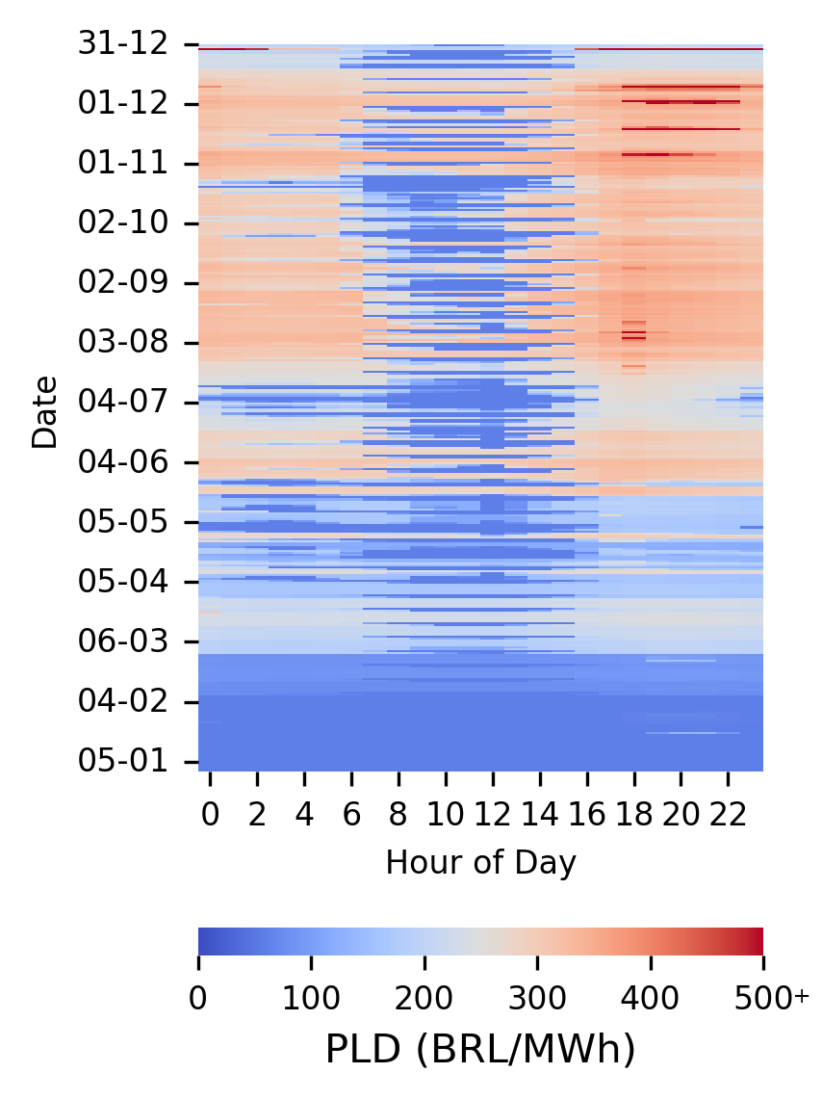
Table 1 summarizes the distribution of daily maximum price spreads, both in absolute terms and relative to the minimum daily price. These values indicate significant intra-day price variability, with median spreads exceeding 150% and upper quartile values above 400%. Such large spreads suggest substantial opportunities for load shifting and flexible operation, as electricity consumption can be shifted from high-price to low-price periods. This reinforces the economic potential of demand-side flexibility in the Brazilian system.
Table 1. Quartiles of maximum daily price spreads in the Southeast-Centerwest subsystem.

Quartile | Price spread  (BRL MWh⁻¹) | Price spread  (%)
Minimum | 0 | 0.0%
25% | 42.57 | 15.8%
50% | 169.11 | 156.2%
75% | 261.975 | 440.2%
Maximum | 1105.19 | 1418.2%

These spreads indicate strong temporal price signals that can incentivize flexible electricity consumption. These results highlight the significant potential of demand-side flexibility in Brazil, particularly in light of recent curtailment levels, and reinforce the need for further research tailored to the specific characteristics of the Brazilian system. In this context, the implementation of additional mechanisms should be further studied. One example is the Spanish energy saving certificate scheme, within the framework of the European Energy Efficiency Directive (Directive (EU) 2023/1791), which allows energy efficiency projects to be implemented and the resulting savings to be traded in a dedicated market (Spain, 2023), leading to 8.06 TWh from November 2023 to February 2026 (MITECO, 2026).
  - Conclusions
This work analyzed renewable energy curtailment and electricity price dynamics in Brazil, highlighting the growing need for demand-side flexibility in systems with high renewable penetration. The results show that curtailment levels in 2025 were significant, both for wind and solar generation and for hydropower operation, with strong temporal patterns linked to solar production and seasonal hydrology. Additionally, the observed electricity price spreads indicate substantial opportunities for load shifting and flexible operation.
In this context, flexible electrification emerges as a promising strategy to both mitigate curtailment and reduce operational costs, particularly in industrial applications where demand can be adjusted in time. Despite increasing attention to energy storage solutions, demand-side flexibility remains underexplored in Brazil. The results presented here reinforce the importance of developing policies, market mechanisms, and process-level strategies that enable flexible consumption. Future work should focus on modeling frameworks and case studies tailored to the Brazilian system, including the integration of thermal storage and partial-load operation strategies.
  - Acknowledgements
The authors gratefully acknowledge financial support from the National Council for Scientific and Technological Development – CNPq (Brazil), processes 307705/2025-0, 309026/2022-9, and 406544/2023-9, and the Coordenação de Aperfeiçoamento de Pessoal de Nível Superior – Brasil (CAPES), process 88881.220090/2025-01 and Finance Code 001.
  - References
ANEEL: NOTA TÉCNICA CONJUNTA No 13/2025-SGM-SCE-STD-STE-STR-SFT/ANEEL - Fechamento da segunda fase da Consulta Pública no 39/2023, https://antigo.aneel.gov.br/consultas-publicas, 2025.
A. Buonomano, C. Forzano, G. F. Giuzio, A. Palombo, G. Russo, and S. Zizzania: The flexibility-efficiency nexus in industrial heat electrification: Optimal operation of heat pump-storage systems under variable electricity price, Energy Conversion, and Management (352), 121109, 2026.
CCEE: Dados abertos CCEE, https://dadosabertos.ccee.org.br/dataset, 2026.
M. Cegla, R. Semrau, F. Tamagnini and S. Engell: Flexible process operation for electrified chemical plants, Current Opinion in Chemical Engineering (39), 100898, 2023.
EPE: Consumo mensal de energia elétrica por classe (regiões e subsistemas), https://www.epe.gov.br/pt/publicacoes-dados-abertos/publicacoes/consumo-de-energia-eletrica, 2026.
L. Göke, J. Weibezahn, and M. Kendziorski: How flexible electrification can integrate fluctuating renewables, Energy (278), 127832, 2023.
L. Knorr, N. Buchenau, F. Schlosser, D. Divkovic, M. G. Prina, and H. Meschede: Electrification and flexibility of process heat in energy system modelling: A review, Renewable and Sustainable Energy Reviews (216), 115698, 2025.
Z. Mekidiche, J. A. Labarta and J. A. Caballero: Optimal design of heat pump assisted thermally coupled distillation sequences, Applied Thermal Engineering (274), 126753, 2025.
Z. Mekidiche, J. A. Labarta, J. Javaloyes-Anton and J. A. Caballero: From power to heat: Strategies for electrifying distillation for sustainable chemical processes, Applied Thermal Engineering (257), 124316, 2024.
A. Mellot, C. Moretti, A. Nuñez-Jimenez, J. Linder, N. Moro, S. Powell, J. Markard, C. Winzer, and A. Patt: Electrification, flexibility or both? Emerging trends in European energy policy, Energy Policy (206), 114725, 2025.
MITECO (Ministerio para la Transición Ecológica y el Reto Demográfico): Seguimiento del Sistema de CAE, https://www.miteco.gob.es/es/energia/eficiencia/cae/seguimiento-del-sistema-de-cae.html, 2026.
MME: Portaria Normativa MME No 111, de 18 de junho de 2025, https://www.gov.br/mme/pt-br/acesso-a-informacao/legislacao/portarias/2025, 2025.
H. Onodera, R. , and T. Nakata: Systematic effects of flexible power-to-X operation in a renewable energy system - A case study from Japan, Energy Conversion and Management: X (20), 100416, 2023.
ONS: ONS Open Data Portal, https://dados.ons.org.br/, 2025.
ONS: Acompanhamento das restrições de geração eólica e fotovoltaica, https://www.ons.org.br/Paginas/faq_curtailment.aspx, 2026.
Spain: Real Decreto 36/2023, de 24 de enero, por el que se establece un sistema de Certificados de Ahorro Energético, Boletín Oficial del Estado (BOE), 2023. https://www.boe.es/eli/es/rd/2023/01/24/36
W. N. Silva, G. G. T. T. Vieira, E. E. Rego, L. F. C. Simone, L. F. N. Lourenço, and M. B. C. Salles: Curtailment pressures and grid flexibility in Brazil: Lessons from the fast-rising distributed generation, Utilities Policy (99), 102148, 2026.
G. T. T. Vieira, W. N. Silva, L. F. N. Lourenço, R. M. Monaro, M. B. C. Salles, and C. F. M. Almeida: Characterizing wind and solar curtailment in Brazil: an evidence-based analysis of operational drivers, Electric Power Systems Research (254), 112672, 2026.

