A Hybrid ResNet Architecture for Predicting Polymerization Conditions from Microstructural Data
Alexandre Eurício Álvaro Antunesª, João B. P. Soares^{b}, Amanda Lemette Teixeira Brandão^{a*}
ª Pontifical Catholic University of Rio de Janeiro, Department of Chemical and Materials Engineering
^{b} University of Alberta Canada, Department of Chemical Engineering
*amanda.lemette@puc-rio.br
ABSTRACT
Modeling polymerization reactions is often hindered by experimental data scarcity. This study proposes a novel hybrid Residual Network (ResNet) architecture to predict operational reactor conditions: pressure, catalyst ratio, C8 preload, and run length directly from microstructural polymer data. Utilizing 2D tensors derived from Molecular Weight and Short-Chain Branching distributions, the deep learning model bifurcates into simultaneous regression and classification branches. To accurately predict the continuous run length, a mathematical expectation approach was introduced, smoothly mapping discrete softmax probabilities into continuous temporal estimates. The hybrid framework demonstrated strong predictive performance, with R² scores above 0.98 for continuous regression variables and 0.73 for the classification-derived run length. Errors were confined to data-scarce intervals. Ultimately, this multi-objective methodology effectively mitigates inherent data limitations, significantly outperforming exclusive single-task networks and providing a robust solution for advanced polymer process modeling.
Keywords: Polymerization, Deep Learning, ResNet, Data Scarcity.

- Introduction
Plastics have established themselves as indispensable materials in contemporary society, encompassing a vast array of applications ranging from food packaging and furniture to highly specialized items such as heart valves and military helmets. Polyethylene (PE), with the general formula (C₂H₄)ₙ, is one of the most widely used polymers globally due to its chemical inertness, low cost, and high mechanical strength. The properties of polyethylene vary significantly depending on its diverse range of chain architectures and molecular weights, which are heavily dependent on the synthesis process (Mejia et al., 2021).
The microstructure of the polymer chain plays a fundamental role in the overall performance of PE. This microstructure is strongly governed by characteristics such as the Short-Chain Branching Distribution (SCBD) and the Molecular Weight Distribution (MWD) (Soares & McKenna, 2012). When both SCBD and MWD are tightly controlled, PE exhibits excellent mechanical properties alongside highly efficient processability (Hu et al., 2019).
The application of Artificial Intelligence (AI) has become increasingly prevalent in the field of polymer science, aiming to accelerate material development and solve complex synthesis and characterization problems. However, a pervasive challenge in this domain is the scarcity or severe imbalance of datasets. As argued by Ge et al. (2025), the two primary bottlenecks regarding polymer datasets are the fundamental lack of available data and the poor quality of existing records. This is corroborated by Xie et al. (2025), who emphasize that polymer datasets are frequently insufficient, unbalanced, and plagued by low signal-to-noise ratios, missing values, and outliers. They highlight that feature engineering must evolve to reduce the heavy reliance on expert-annotated labels and eliminate redundant, low-information features to effectively cluster patterns. Furthermore, Wei et al. (2022) point out that data derived from real physical experiments inevitably suffers from inadequate sample sizes, primarily due to the high costs and logistical constraints associated with comprehensive experimental runs. Consequently, there is an urgent demand for robust scientific algorithms capable of enabling effective machine learning modeling even when restricted to small datasets.
Therefore, the present work aims to explore a novel methodology and a deep learning architecture designed to effectively mitigate the challenges associated with data scarcity and class imbalance in polymerization process modeling.

2. Methodology
This section details the methodologies applied in this study, encompassing the data preprocessing protocols, the data augmentation strategy, and the architectural design of the Residual Network (ResNet).

2.1 Dataset and Pre-processing
The MWD and SCBD graphs were generated from 111 experiments conducted at the University of Alberta in Canada, using the GPC Technique. However, unlike the original study, in order to avoid data leakage, the dataset was split into 50% for data augmentation and 50% for testing.
The data augmentation is based on the work of Brandão et al., 2016 and Chiara et al., 2025, the generation of synthetic samples was based on the stochastic perturbation of the Molecular Weight M values, applying a random error factor (δ) of up to 10%, as described in Equation 1:

$$M_{New}= M_{original} * (1+δ ) (1)$$
where 𝛿 is randomly selected in the range [-0.1; +0.1]. The quantification of this augmentation followed a differential sampling strategy, a higher multiplication factor was applied: while 15 synthetic variations were generated for the standard experimental data, 35 variations per sample were generated for the outliers.
After the augmentation step, the graphs were processed into single-channel binary tensors (inverted grayscale) and associated with their respective process condition labels, Figure 1 shows this process. The target variables P(psi) and [Al]/[Ti] were normalized using StandardScaler to ensure numerical stability during training.

Figure 1: MWD and SCBD graphs converted into single-channel binary tensors.

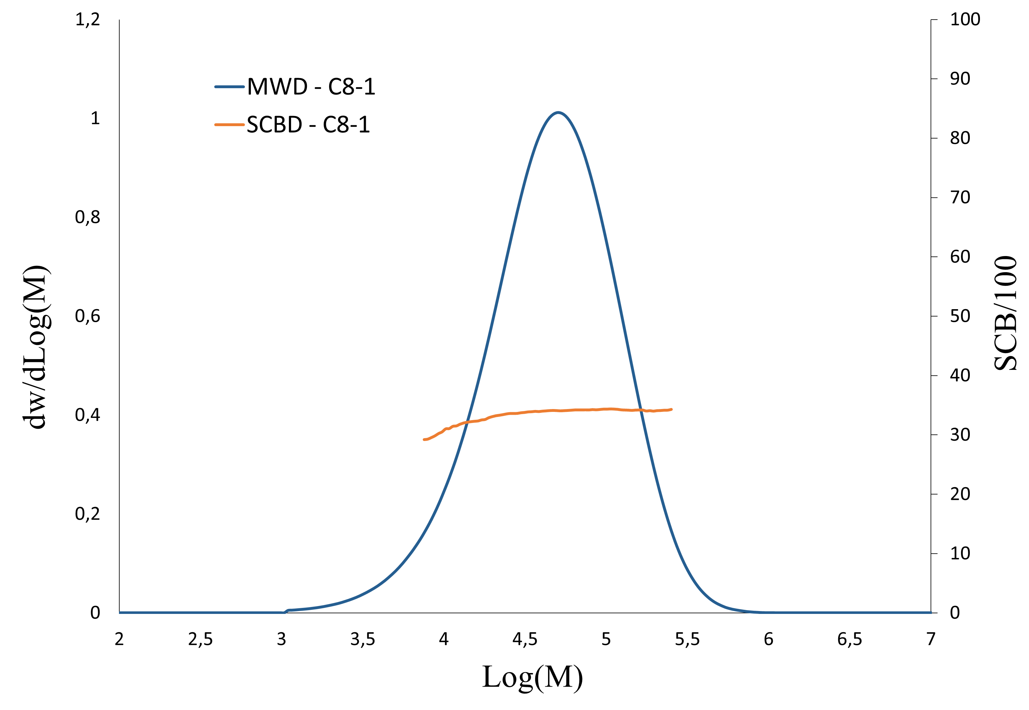 | 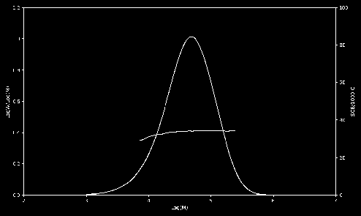
- Original MWD and SCBD graphs | - Treated MWD and SCBD graphs

An 80/20 train–validation split was applied to the augmented dataset. The test set consisted exclusively of 56 original data points, which were not used in the augmentation or training steps.

2.2 Resnet Configuration
The Resnet network structure receives input tensors of shape (295, 494, 1). The feature extraction backbone is based on a Residual Network (ResNet) architecture. It begins with a stem block comprising a 7 X 7 convolutional layer (32 filters, stride 2, He normal initialization), followed by batch normalization, ReLU activation, and a 3 X 3 max pooling layer (stride 2). This is followed by a sequence of eight residual blocks with skip connections to mitigate the vanishing gradient problem. These blocks progressively increase the number of feature maps, organized in pairs with 64, 128, 256, and 512 filters. A stride of 2 is applied in the first block of each new filter group to reduce spatial dimensions while capturing finer textural features.
Following the convolutional backbone, a Global Max Pooling 2D layer is applied to collapse the spatial dimensions, feeding into a fully connected dense layer with 256 neurons (ReLU activation) and a dropout rate of 0.3. To address the multi-objective nature of the problem, a hybrid architecture was implemented, branching into two distinct output heads. The regression branch consists of a dense layer with three neurons and linear activation to predict continuous variables. In parallel, the classification branch employs a dense layer with softmax activation to output class probabilities for the run length variable.
The training process was configured for a maximum of 200 epochs to accommodate the depth of the ResNet. To ensure optimal convergence and prevent overfitting, a robust callback strategy was implemented. This included early stopping, configured to halt training after 25 epochs without improvement in validation loss (restoring the best weights); ReduceLROnPlateau, which halves the learning rate after 10 epochs of stagnation (down to a minimum of 1e-6); and ModelCheckpoint, which continuously saves the best-performing model based on validation loss.
To handle the dual outputs of the hybrid architecture, a composite loss function was applied during training. The regression branch was optimized using the Mean Squared Error (MSE), defined by Equation 2:

$$MSE=\frac{1}{n}\sum_{i=1}^{n}{{\left(y_{i}-\hat{y_{i}}\right)}^{2}} (2)$$

Simultaneously, the classification branch was optimized using Categorical Cross-Entropy $\left(L_{CCE}\right)$ with a label smoothing factor of alpha = 0.1 to prevent overconfidence in predictions. For a problem with K classes, the smoothed target probability $y_{i,c}^{LS}$ and the loss are defined by Equations 3 and 4:

$$y_{i,c}^{LS}=y_{i,c}\left(1-α\right)+\frac{α}{K} (3)$$
$$L_{CCE}=-\sum_{c=1}^{K}{y_{i,c}^{LS}log\left(p_{i,c}\right) } (4)$$

where $p_{i,c}$ is the predicted Softmax probability for class c. To balance the gradients during backpropagation, loss weights of $λ_{reg}=and λ_{cls}=5.$ were assigned to the regression and classification outputs, respectively, resulting in the total loss function:

$$L_{Total}=λ_{reg}MSE+λ_{cls}L_{CCE} (5)$$

Mathematical Expectation for Continuous Estimation on the context of polymerization reactor operation, the Run Length must ultimately be output as a continuous variable to effectively inform process control decisions and operational planning. While treating this variable categorically helped overcome specific data distribution challenges during training, a discrete class output is insufficient for practical engineering application.
To bridge this gap and evaluate the categorical predictions using continuous metrics, a mathematical expectation approach was introduced. Instead of simply selecting the class with the highest probability via an argmax function, the final continuous estimation $\left(\hat{y_{exp}}\right)$ was calculated as the weighted sum of the Softmax output probabilities $p_{c }$and their respective predefined class centers or bins $\left(V_{c}\right):$
$$E\left[\hat{y_{exp}}\right]=\sum_{c=1}^{K}{p_{c}⋅V_{c} } (6)$$
This methodology allows for a smooth, continuous mapping of the discrete classification output, capturing the probabilistic distribution of the predictions and providing a realistic numerical value for the reaction timeframe.
Consequently, the performance of the run length variable could be evaluated alongside the regression variables using the coefficient of determination $\left(R^{2}\right)$and the Mean Absolute Percentage Error (MAPE):

$$R^{2}=1-\frac{\sum_{i=1}^{n}{{\left(y_{i}-\hat{y_{i}}\right)}^{2}}}{\sum_{i=1}^{n}{{\left(y_{i}-\underline{y}\right)}^{2}}} (7)$$

$$MAPE=\frac{100\%}{n}\sum_{i=1}^{n}{\left|\frac{y_{i}-\hat{y_{i}}}{y_{i}}\right|} (8)$$
3. Results and Discussion

Figure 2 illustrates the data distribution following the augmentation process. It is evident that the augmented data did not fully span the entire domain of the test set. While the three continuous regression variables exhibit adequate distributional overlap between the training/validation and test splits, the Run Length (min) variable suffers from data scarcity in specific intervals. Notably, there is a lack of representative data in the 10–20 and 20–30 minute ranges. This distribution gap in the training set accounts for the comparatively lower predictive performance observed for this specific variable during testing.

Figure 2: Data Distribution

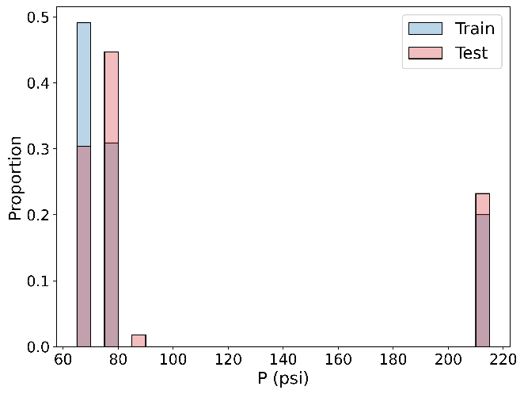 | 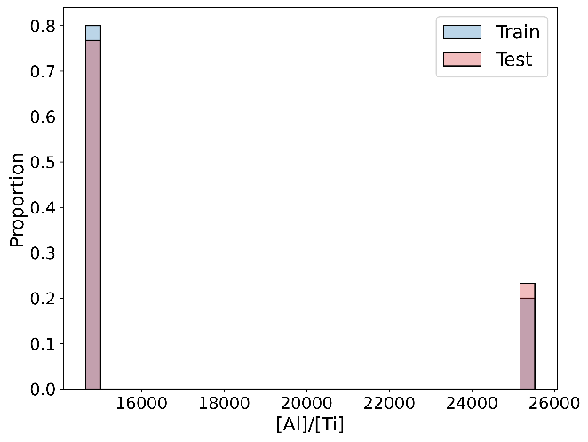
- Distribution of pressure (psi) | - Distribution of catalyst ratio
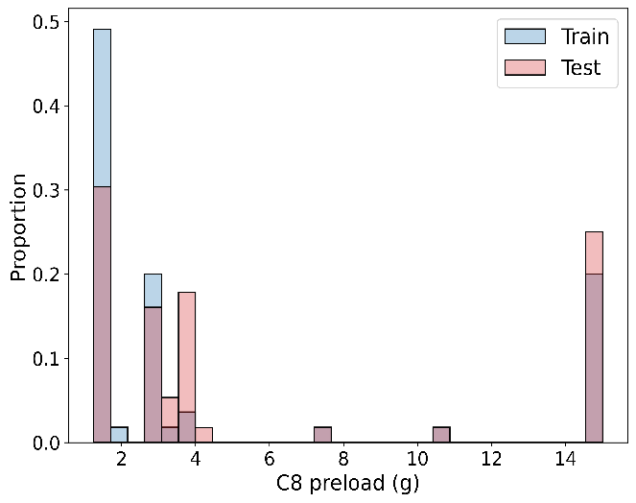 | 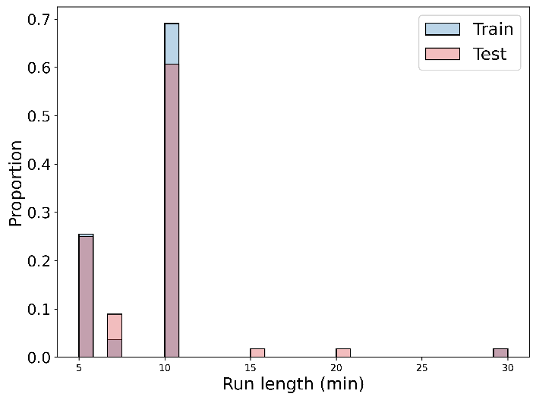
(c) Distribution of C8 preload | (d) Distribution of Run Length

The model was trained locally using an Intel i5-13400F processor, 16 GB of RAM, and an NVIDIA GeForce RTX 3060 GPU, reaching convergence in 27 minutes, using TensorFlow. The training, validation, and test metrics for the continuous outputs and the estimated Run Length are summarized in Table 1.

Table 1: Regression Results
Variables | Train  R² | MAPE(%) | Val  R² | MAPE(%) | Test  R² | MAPE(%)
Pressure (psi) | 0.99|4.11 | 0.99|3.90 | 0.99|5.08
Catalyst Ratio [Al]/[Ti] | 0.98|1.83 | 0.98|1.72 | 0.89|2.78
C8 Preload (g) | 1.00|2.99 | 1.00|5.34 | 1.00|9.16
Run Length (min) | 0.99|3.63 | 0.99|3.85 | 0.73|11.29

The results in Table 1 demonstrate that the regression-based variables achieved high predictive performance, while the "run length (min)" variable exhibited an intermediate level of performance.
The performance for run length within the hybrid framework significantly outperformed the benchmarks where the model was configured either entirely for regression or entirely for classification across all variables.
A comparative analysis of the test results reveals the limitations of a purely regressive approach for temporal variables: the regression-only model yielded a poor R² of 0.02 and a MAPE of 12.57% for run length, in contrast, by treating Run Length as a categorical output and applying the mathematical expectation method, the model achieved an R² of 0.68 and a MAPE of 9.13%.
While the classification only model showed similar metrics for run length, it caused a severe degradation in the prediction of the remaining continuous variables, with R² values dropping to zero and a substantial increase in MAPE. These findings underscore that the proposed hybrid ResNet architecture is the most robust configuration, as it optimizes the feature extraction process for both continuous chemical parameters and discretized reaction timeframes simultaneously.

Figure 3: Confusion Matrix for Run Length
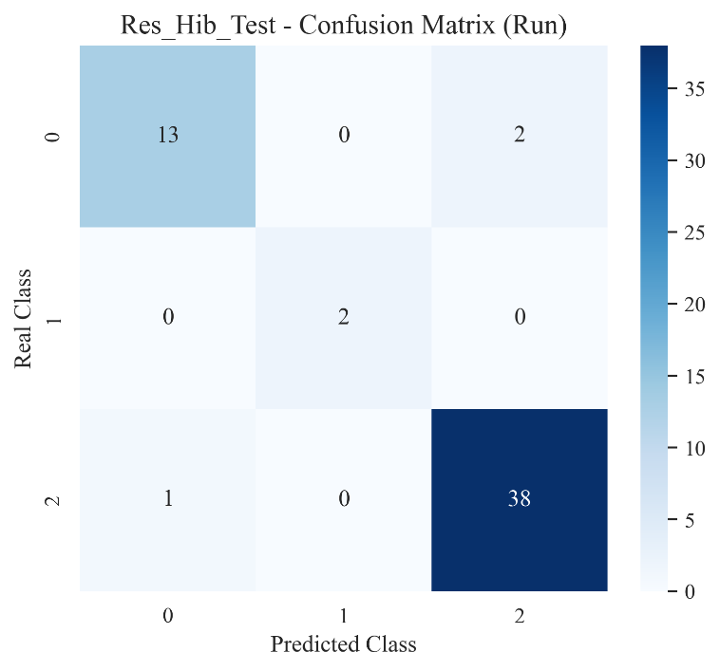

The confusion matrix presented in Figure 2 demonstrates that misclassifications are concentrated precisely within the intervals suffering from data scarcity. Out of 56 total test samples, the model yielded only 3 errors, underscoring a high overall classification accuracy. Specifically, two instances belonging to the lower operational range (Class 0) were incorrectly classified into the highest range (Class 2), while one instance from the higher range (Class 2) was erroneously assigned to the lower range (Class 0). These specific misclassifications align directly with the distribution gaps identified in the augmented dataset, confirming that the lack of representative data in the intermediate ranges (10–20 and 20–30 minutes) was the primary driver for these isolated errors.

4.Conclusion
The proposed hybrid ResNet architecture demonstrated robust predictive performance, successfully generalizing the continuous regression variables with R² scores exceeding 0.98 and MAPE's strictly below 10%. Regarding the classification variable, run length, the model yielded an R² of 0.73. While this performance is comparatively lower than that of the continuous variables, it represents a significant predictive capability. Analysis of the confusion matrix confirmed the model's strong aptitude for correctly assigning operational classes and, consequently, generating accurate continuous estimates via mathematical expectation. The isolated prediction errors were strictly confined to ranges suffering from inherent data scarcity. Ultimately, comparative evaluations establish that the proposed hybrid architecture significantly outperforms exclusive single-task networks, proving to be a highly effective and superior approach for handling this problem.

Acknowledgments: This study has been financially supported by the Human Resources Training Program of the Brazilian National Agency for Petroleum, Natural Gas and Biofuels – PRH-ANP; project no. 2025/02828-3. The authors also would like to thank FAPERJ for the Jovem Cientista do Nosso Estado grants awarded to Amanda L.T. Brandão.

References

A. L. Brandão, J. B. P. Soares, J. C. Pinto e A. L. Alberton: Comparison of different dynamic Monte Carlo methods for the simulation of olefin polymerization, Macromolecular Symposia (360), 160–178, 2016.
I. Chiara, S. Obaidoon, J. Neto, J. Soares e A. Brandão: Prediction of polymerization reaction conditions via convolutional neural network, XXIV Congresso Brasileiro de Engenharia Química (COBEQ), Belo Horizonte, MG, Brasil, 2025.
W. Ge, R. D. Silva, Y. Fan, S. A. Sisson e M. H. Stenzel: Machine Learning in Polymer Research, Advanced Materials, 2025. https://doi.org/10.1002/adma.202413695
Y. Hu, Y. Shao, Z. Liu, X. He e B. Liu: Dominant effects of short-chain branching on the initial stage of nucleation and formation of tie chains for bimodal polyethylene as revealed by molecular dynamics simulation, Polymers (11), 1840, 2019.
E. Mejia, N. Cherupurakal, A.-H. I. Mourad, S. Al Hassanieh e M. Rabia: Effect of processing techniques on the microstructure and mechanical performance of high-density polyethylene, Polymers (13), 3346, 2021.
J. B. P. Soares e T. F. L. McKenna: Polyolefin reaction engineering, Wiley-VCH: 2012.
S. Wei, Z. Chen, S. K. Arumugasamy e I. M. L. Chew: Data augmentation and machine learning techniques for control strategy development in bio-polymerization process, Environmental Science and Ecotechnology (11), 100172, 2022.
C. Xie et al.: Machine Learning Approaches in Polymer Science: Progress and Fundamental for a New Paradigm, SmartMat (6), 2025.

