Glycerol Prospects in Industry Defossilization: Production of Low-Carbon Hydrogen, Ammonia, and Methanol
Kevin Mitsuhiro Omori^{a,b*}, Lucas Maximiliano Machin Ferrero^{b}, Fernando Daniel Mele^{b}, Mauro Antonio da Silva Sá Ravagnaniª, Leandro Vitor Pavãoª, Caliane Bastos Borba Costaª
ªState University of Maringá, Chemical Engineering Graduated Program, Maringá-PR, Brazil
^{b}Universidad Nacional de Tucumán, Facultad de Ciencias Exactas y Tecnología, Departamento de Ingeniería de Procesos y Gestión Industrial, San Miguel de Tucumán, Tucumán, Argentina
*kevinmitsuhiro.09@gmail.com
ABSTRACT

Considering the need for defossilization of the chemical industry and the surplus production of glycerol, the present work evaluates the production of hydrogen, methanol, and ammonia from the steam reforming of glycerol. To this end, the process was simulated, and the life cycle assessment was used to estimate its environmental performance. From the proposed method, a sensitivity analysis was built, verifying the effect of the fraction of hydrogen produced that is destined for the production of ammonia and the temperature of the reactor for this production. Within the analyzed range, the best result found was when a fraction of 60% of the hydrogen was used, and the production of ammonia was at 640 K, when the process presented emission of -1.53 kg CO₂eq per kilogram of glycerol processed.

Keywords: Process Simulation; Life Cycle Assessment; Glycerol Steam Reforming.
  - Introduction
The reduction of greenhouse gas emissions in order to curb climate change and the increase in the global average temperature is one of the main international challenges today. The development of technologies that allow the reduction of fossil-derived carbon emissions, however, is still limited, and when developed, new technologies still suffer economic obstacles when compared to traditional technologies (Rootz, 2021).
In the decarbonization (referring to fossil carbon) of energy-intensive industrial sectors, hydrogen (H₂) stands out when produced from renewable sources (Augusto et al., 2025). Although widely recognized as a key driver of decarbonization, H₂ is still mostly produced from fossil sources (from the steam reforming of methane, SMR) (Luo et al., 2025), and, while it is a base chemical in the production of several other widely used chemicals, such as ammonia and methanol, its production impacts the emission profiles of these other products. Ammonia, for example, is a high-demand product, essential in the production of fertilizers and therefore in the production of food (Ojelade et al., 2023), but 90% of the legacy impact of the ammonia produced comes from the production of H₂ through SMR (The Royal Society, 2020). Another widely used component that also comes from H₂ is methanol. Produced industrially from syngas, methanol has direct application in the production of multiple chemicals and fuels (Onishi & Himeda, 2024). Similar to ammonia, the development of methanol production processes with low environmental impact through the use of renewable H₂ has gained prominence (Cuezzo et al., 2023). Therefore, the production of H₂ from renewable sources, and subsequently from its derivatives, would surely promote a significant reduction in emissions from the industrial sector.
One of the possible ways to produce H₂ from biomass is the steam reforming of glycerol. Glycerol is a byproduct of biodiesel production, which, with the increased use of this biofuel, has been overproduced. The surplus of glycerol in the market leads to low prices, particularly in its raw form, making the production of higher-value H₂ from glycerol more attractive.
Many studies have been published with respect to steam reforming glycerol, given the prospects surrounding low-carbon H₂. Taipabu et al. (2023), for example, proposed a process for the production of electricity, H₂, and urea from glycerol and optimized the process using as decision variables the glycerol/water molar ratio, and the reforming temperature and pressure. Among the three scenarios analyzed by the authors, the first and second allowed a specific production of 0.152 kg_{H2}/kg_{gly} and 0.587 kg_{urea}/kg_{gly}, while the third reached only 0.038 kg_{H2}/kg_{gly} and 0.293 kg_{urea}/kg_{gly}, being able to completely meet its energy demand with a production of 33.2 MW of power.
Considering the multiplicity of products that can be obtained from glycerol, there is still a wide scope for searching to identify and synthesize processes that ensure, in addition to economic feasibility, a lower environmental impact. In this sense, the present work aims to evaluate one of these systems, producing methanol, H₂, and ammonia from glycerol, considering the effect of the variation of operating conditions on the expected environmental impact of the process.
  - Method
In order to evaluate a multi-product biorefinery for the co-production of low-carbon H₂, ammonia, and methanol from glycerol, the process was simulated using the Aspen HYSYS® v15 software, and a Python connection was made to the Brightway® software package in order to determine its emission profiles. The methodology adopted for each stage is described in the following subsections.

    - Process simulation
The process is summarized according to the simplified flowchart presented in Figure 1. For the simulation, the thermodynamic packages SRK and NRTL were used to determine the properties of the gas and liquid phases, respectively.

Figure 1. Simulated process flowsheet.
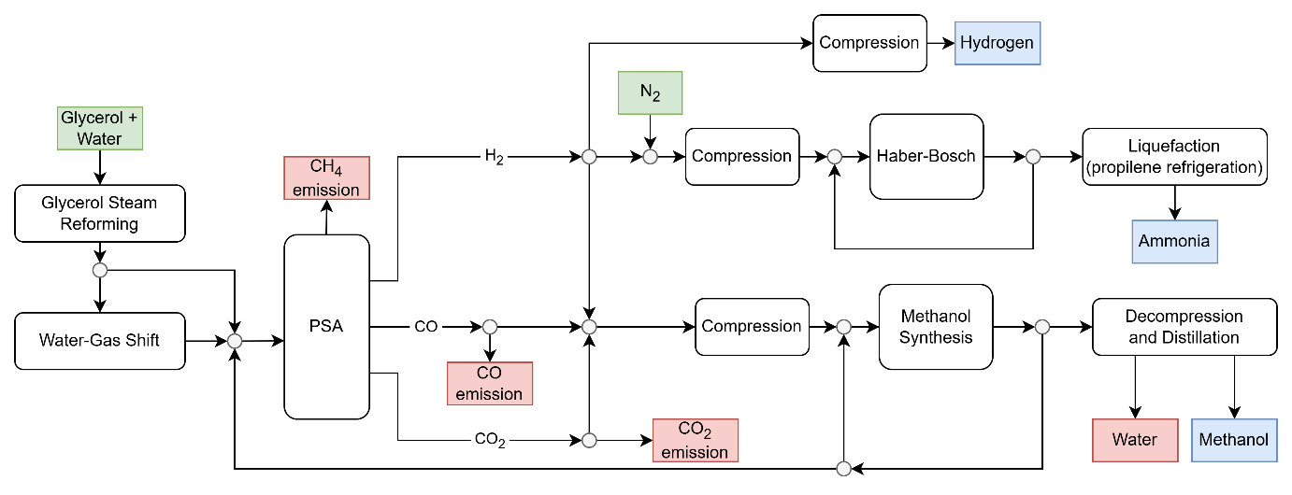

The process begins with a feed stream of vaporized glycerol and water, with a glycerol/water molar ratio of 1:12, which is fed to the reforming reactor. For the present study, a calculation basis of 5 t/h of glycerol was considered. The reaction was simulated as a Gibbs reactor operating at 500 °C and 1 bar. For the reforming, the equilibrium condition was adopted, as high operating temperatures and sufficient residence times are expected to favor near-equilibrium conditions. Nevertheless, the concentrations of methane and carbon monoxide (CO) produced were adjusted by setting component flow specs to reflect experimental data reported by Sadanandam et al. (2012) for the reforming reaction under the same simulated conditions. The syngas obtained is fractionated: 70% is directed to the water-gas shift reactor (WGS), promoting a greater conversion of the CO. By not subjecting all the syngas to the shift process, it is guaranteed that there will be enough CO for the production of methanol. The reaction of WGS, at a temperature of 300 °C and 1 bar, was simulated from kinetic parameters reported by Choi & Stenger (2003) in a plug flow reactor.
The WGS product, mixed with the remaining syngas, is sent to a separation unit by pressure swing adsorption (PSA). The process was simulated in the software component separator blocks, and the operating pressures and separation efficiency of each bed were considered according to the methodology proposed by Puig-Gamero et al. (2018). From the separation unit, three product streams are obtained: H₂, CO, and carbon dioxide (CO₂), as well as a residual stream that contains methane in addition to losses of the other components.
The H₂ stream is divided into three fractions: the first one is destined for sale, the second for the production of ammonia, and the rest for the production of methanol. H₂ destined for sale goes through a compression cycle with inter-stage cooling (300 K) up to 200 bar, considering the commercialization pressure. The second fraction is intended for the production of ammonia. In this stream, nitrogen is added in a stoichiometric proportion according to the Haber-Bosch (HB) process. The mixture is then compressed to 150 bar, again in a compression cycle with inter-stage cooling, and heated to reaction temperature, to then be fed to the reactor. The HB reaction was simulated from the kinetics presented by Araújo & Skogestad (2008). The reactor product is cooled by a propylene refrigeration cycle, so that the ammonia is liquefied and removed in a separation vessel, while the unconverted reactants are recycled into the reactor. In this study, the H₂ fraction destined for ammonia production ($x$) and the temperature of the HB reactor ($T$) were considered as input variables for the analysis of the process sensitivity. The analysis range of the H₂ fraction for the production of ammonia was from 20% to 65% of the H₂ produced, 20% was fixed for the production of methanol, and the remaining was destined for sale. For the reactor, the analysis comprised the temperature range of 610 K to 780 K.
Finally, the fraction of H₂ sent to the production of methanol is mixed with some of the monoxide and CO₂ separated in the PSA unit. The methanol synthesis reaction strongly depends on parameters such as the carbon oxide ratio (COR), defined as in Equation (1), and the stoichiometric number (SN), defined as in Equation (2) (Nestler et al., 2020), where $y_{H_{2}}$, $y_{{CO}_{2}}$, and $y_{CO}$ represent the molar fractions of H₂, CO₂, and CO in the reactor feed, respectively. For the present study, fixed values of COR = 0.50 and SN = 2.43 were considered.

$$COR= \frac{y_{{CO}_{2}}}{y_{CO}+y_{{CO}_{2}}}$$ | (1)
$$SN= \frac{y_{H_{2}}-y_{{CO}_{2}}}{y_{CO}+y_{{CO}_{2}}}$$ | (2)
Analogously to the production of ammonia, the reactant mixture is pressurized to 70 bar and heated to 280 °C before being fed into the reactor. The reactor, in turn, was simulated from the kinetic data reported by Nestler et al. (2020). The reactor product is cooled to room temperature to remove the liquid phase rich in water and methanol. The vapor, rich in H₂ and unreacted carbon oxides, is recycled to the PSA stage while the liquid phase is decompressed and fed to a distillation column, from where methanol is obtained as distillate to a purity of 99.9%, with a loss of 0.1% in the water stream at the bottom of the column.

    - Environmental efficiency evaluation: life cycle assessment
To evaluate the environmental performance of the simulated system, a life cycle analysis (LCA) was performed. For this purpose, the Brightway package and the Ecoinvent 3.12 database in Python were used. The algorithm built varied the decision variables in the simulator and imported the inputs and outputs of the simulated process, listed in Table 1, to then calculate the impact associated with the production process. In the present study, the IPPC 2021: fossil – Global Warming Potential (GWP100) was chosen as the method of impact assessment, as much of the legislation on low-carbon H₂ is governed by the impact of H₂ in kg CO₂eq.

Table 1. Process inputs and outputs.
Process inputs | Process outputs
Processes from technosphere | Products
Glycerol, from soybean oil esterification | Hydrogen 200 bar (99.99% purity)
Nitrogen, from air separation | Ammonia, liquid (99.77% purity)
Heat, burning wood chips | Methanol, liquid (99.90% purity)
Electricity, high voltage, Brazilian grid | Emissions
Cooling energy, at -45 °C, propylene | Carbon dioxide, to air (biogenic)
Resources | Carbon monoxide, to air (biogenic)
Water, cooling | Methane, to air (biogenic)
Water, process | Methanol to water
 | Water, to water
 | Water, to air

For the present study, glycerol was considered as a residue from biodiesel production, and therefore does not inherit the impacts of biofuel production. Considering the wide production of biodiesel in Brazil, the good adaptability of the glycerol reforming process to the Brazilian reality, and to the technosphere processes, preference was given to processes with Brazilian data. Exceptions include nitrogen and cooling energy, for which production data were not available for Brazil, and global average data were considered. For cooling energy, however, the energy grid used in the process was changed to the Brazilian average grid.
Considering that the proposed process is a multi-product biorefinery, the definition of the functional unit is a central element of the analysis. Given that for each operating condition the production of the tree products is variable, the functional unit is considered as 1 kg of glycerol processed in the biorefinery (5 t/h capacity).
In order to compare the environmental efficiency of each pair of temperature and fraction of hydrogen to produce ammonia, despite the different production profiles, the net impact was evaluated, as shown in Equation (3). In the equation, $I_{N}$ is the net impact of the process, $I_{T}$ is the total impact of the proposed process, $m_{gly}$ is the glycerol mass processed, and $m_{i}$ and ${\hat{I}}_{i}$ are respectively the mass produced of each of the three products, H₂, ammonia, and methanol, and the specific impact of the production of these compounds from traditional methods, which would be avoided. Thus, the net impact evaluates the effective gain, compared to traditional processes, which is reached for each operating condition (and its respective functional unit). For the present work, the impacts associated with the traditional production were taken from the Ecoinvent database, and were 13.29, 2.71, and 1.01 kg CO₂eq/kg for H₂, ammonia, and methanol, respectively.

$$I_{N}= \frac{I_{T}-\sum{m_{i}{\hat{I}}_{i}}}{m_{gly}}$$ | (3)
  - Results and discussion
Initially, for model validation, the present work was compared with data from the literature (Araújo & Skogestad, 2008; Choi & Stenger, 2003; Nestler et al., 2020) in terms of the amounts produced of each product (see Table 2) at each reaction stage, and showed good agreement. The temperature and pressure conditions, as well as the concentrations of the reactants, were selected respecting the limits for which the kinetics were experimentally determined, which justifies the good performance of the model.

Figure 2. HB fraction and temperature effect in GWP100.
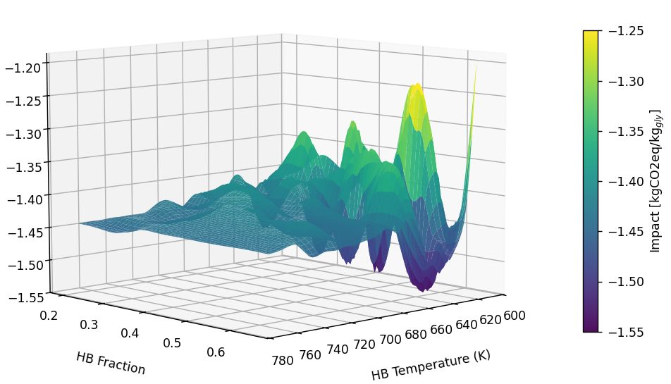

From the proposed simulated process and the impact assessment methodology, varying the fraction of H₂ destined for ammonia production and the temperature of this reactor, the impact profile of the process is shown in Figure 2. The best point found was [0.60,640]. For this operating point, the result indicates that the proposed biorefinery would be able to avoid emissions of 7777.88 kg CO₂eq for the calculation basis adopted, i.e., -1.53 kg CO₂eq/kg_{gly}, by replacing the traditional production processes.
It is interesting to note that, although a single minimum value was found, other regions have impacts that are close to the best impact found. At points [0.45,620] and [0.5,660], for example, the impacts found are similar, of -1.52 and -1.51 kgCO₂eq/kg_{gly}. The determination of these distinct regions could help the profitability of the process, making it possible to vary the fraction produced of each of the three products in order to ensure a good adaptation of the biorefinery to the demand conditions, while maintaining adequate conditions of environmental impact. For example, at the point of best environmental impact, the production of H₂ and ammonia would be 144 kg and 2672 kg, respectively, while for the other two points of operation mentioned, the production would be 252 kg and 2081 kg, or 216 kg and 2180 kg, respectively.
In the condition of the best scenario regarding environmental impact determined from the sensitivity analysis, the life cycle inventory is presented in Table 2, while the contribution of each of the constituent processes to the GWP100 is shown in Figure 3. For this operating condition, the specific production of each component was 0.03 kg_{H2}/kg_{gly}, 0.53 kg_{NH3}/kg_{gly}, and 0.03 kg_{MeOH}/kg_{gly}. The results show that electricity, nitrogen for ammonia production, and the refrigeration cycle with propylene are the three main processes that affect the GWP100 of the process, while heat represents only 13%, given the renewability of the feedstock (wood). It is also noteworthy that glycerol, despite being an input of the process, was considered as a residue of transesterification, and, therefore, without an environmental burden associated with it, thus other forms of allocation could promote different effects. In the same database used, for example, the glycerol produced in Brazil is presented with a GWP100 of 1.11 kg CO₂eq/kg_{gly}. Considering this value, the difference between the proposed process and the traditional ones would be less sensitive, of -0.42 kg CO₂eq per kg_{gly} processed in the biorefinery.

Table 2. Life cycle inventory results.
Streams | Quantity
Inputs
Glycerol | 5079 kg
Nitrogen | 2003 kg
Heat | 70456 MJ
Electrcity | 5132 kWh
Cooling at -45 °C | 10342 MJ
Water, cooling | 884 m³
Water, process | 12 m³
Outputs
Carbon dioxide | 5820 kg
Carbon monoxide | 351 kg
Methane | 116 kg
Methanol | 0.24 kg
Water, to water | 10541 m³
Water, to air | 0.02 m³
Hydrogen | 144 kg
Ammonia | 2673 kg
Methanol | 135 kg

Figure 3. Contribution to total GWP100.
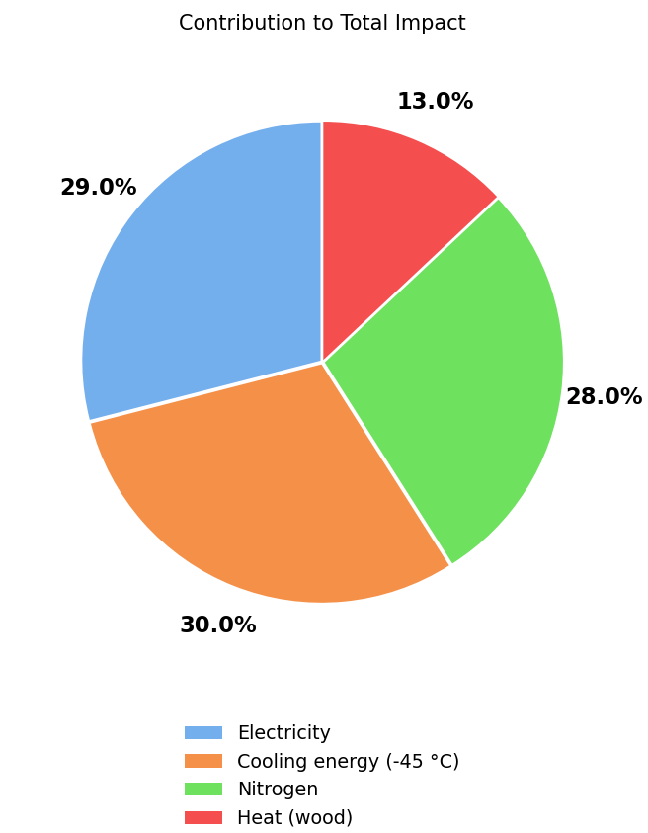
  - Conclusions
The use of low-value-added and highly available compounds such as glycerol can contribute significantly to the defossilization of the chemical industry. In the present study, a biorefinery was simulated to produce ammonia, H₂, and methanol from glycerol steam reforming. The proposed biorefinery design was evaluated from an environmental perspective (GWP100) as a function of the operating conditions of ammonia production. At the best operating point found, the process reached a specific production of 0.03 kg_{H2}/kg_{gly}, 0.53 kg_{NH3}/kg_{gly}, and 0.03 kg_{MeOH}/kg_{gly}, with an emission profile of -1.53 kg CO₂eq/kg_{gly}. The analysis of this multi-product biorefinery also draws special attention to the fact that it is possible to find different operating points that guarantee good environmental performance. In this way, it would be possible to allow a flexibility of the operating conditions to ensure a good adaptability of the process, which could be adjusted to the demand of each product, ensuring economic return, while still producing satisfactory emission profiles. Therefore, future studies could address multi-objective optimizations, which, in addition to environmental parameters, would also maximize the economic return of these processes. Additionally, the number of environmental indicators used could be expanded to assess burden shifting. Economic viability remains one of the main obstacles to the full application of these new technologies in the chemical industry.

Acknowledgments: The authors gratefully acknowledge the Fundação Araucária, the Coordenação de Aperfeiçoamento de Pessoal de Nível Superior – Brasil (CAPES), Finance Code 001 and Processes 309026/2022-9, 406544/2023- 9, and 307705/2025-0, the Universidad Nacional de Tucumán (UNT), and the Argentine Scientific and Technical Research Council (CONICET).

References
Araújo, A. & Skogestad, S. (2008). Control structure design for the ammonia synthesis process. Computers and Chemical Engineering, 32(12), 2920–2932. https://doi.org/10.1016/j.compchemeng.2008.03.001
Augusto, B., Roque, C., Henrique, M., Cavalcanti, C., Pinto, P., Brasileiro, F., Henrique, P., Pereira, R., Alexandre, V., Converti, A., Benachour, M. & Asfora, L. (2025). Hydrogen-powered future : Catalyzing energy transition , industry decarbonization and sustainable economic development : A review. Gondwana Research, 140(October 2024), 159–180. https://doi.org/10.1016/j.gr.2025.01.012
Choi, Y. & Stenger, H. G. (2003). Water gas shift reaction kinetics and reactor modeling for fuel cell grade hydrogen. Journal of Power Sources, 124(2), 432–439. https://doi.org/10.1016/S0378-7753(03)00614-1
Cuezzo, A. M., Araujo, P. Z., Wheeler, J. & Mele, F. D. (2023). Modeling and environmental implications of methanol production from biogenic CO2 in the sugarcane industry. Journal of CO2 Utilization, 67(November 2022), 102301. https://doi.org/10.1016/j.jcou.2022.102301
Luo, G., Zhao, Z. T., Ding, J., Yang, S. S., Yu, X. L., Bao, M. Y., Sun, H. J., Pang, J. W., Zhang, L. Y. & Ren, N. Q. (2025). Comparative review of carbon emissions from hydrogen production technologies: The hydrogen color characteristic of biomass-based manufacturing. Renewable and Sustainable Energy Reviews, 217(March), 115756. https://doi.org/10.1016/j.rser.2025.115756
Nestler, F., Schütze, A. R., Ouda, M., Hadrich, M. J., Schaadt, A., Bajohr, S. & Kolb, T. (2020). Kinetic modelling of methanol synthesis over commercial catalysts: A critical assessment. Chemical Engineering Journal, 394(December 2019), 124881. https://doi.org/10.1016/j.cej.2020.124881
Ojelade, O. A., Zaman, S. F. & Ni, B. J. (2023). Green ammonia production technologies: A review of practical progress. Journal of Environmental Management, 342(February), 118348. https://doi.org/10.1016/j.jenvman.2023.118348
Onishi, N. & Himeda, Y. (2024). Toward Methanol Production by CO2 Hydrogenation beyond Formic Acid Formation. Accounts of Chemical Research, 57(19), 2816–2825. https://doi.org/10.1021/acs.accounts.4c00411
Puig-Gamero, M., Argudo-Santamaria, J., Valverde, J. L., Sánchez, P. & Sanchez-Silva, L. (2018). Three integrated process simulation using aspen plus®: Pine gasification, syngas cleaning and methanol synthesis. Energy Conversion and Management, 177(September), 416–427. https://doi.org/10.1016/j.enconman.2018.09.088
Rootz, J. (2021). Brick by brick : Governing industry decarbonization in the face of uncertainty and risk. 40(June), 189–202. https://doi.org/10.1016/j.eist.2021.07.002
Sadanandam, G., Sreelatha, N., Phanikrishna Sharma, M. V., Kishta Reddy, S., Srinivas, B., Venkateswarlu, K., Krishnudu, T., Subrahmanyam, M. & Durga Kumari, V. (2012). Steam Reforming of Glycerol for Hydrogen Production over Ni/SiO2 Catalyst. ISRN Chemical Engineering, 2012, 1–10. https://doi.org/10.5402/2012/591587
Taipabu, M. I., Viswanathan, K. & Wu, W. (2023). Process design and optimization of green processes for the production of hydrogen and urea from glycerol. International Journal of Hydrogen Energy, 48(63), 24212–24241. https://doi.org/10.1016/j.ijhydene.2023.03.163
The Royal Society. (2020). Ammonia : zero-carbon fertiliser, fuel and energy store. In Ammonia: zero-carbon fertiliser, fuel and energy store. https://royalsociety.org/-/media/policy/projects/green-ammonia/green-ammonia-policy-briefing.pdf

