Voltage-Driven Electro-Spray and Optoelectronic Evaluation of Gadolinium-Doped Zirconium Sulphide Thin Films for Enhanced Optoelectronic Applications

Samuel O. Shaka¹, Godfrey E. Akpojotor², Merrious O. Ofomola³, Cletus Olisenekwu⁴
¹Delta State University, Abraka. Delta State, Nigeria
²Delta State University, Abraka. Delta State, Nigeria
³Delta State University, Abraka. Delta State, Nigeria
⁴Delta State University, Abraka. Delta State, Nigeria

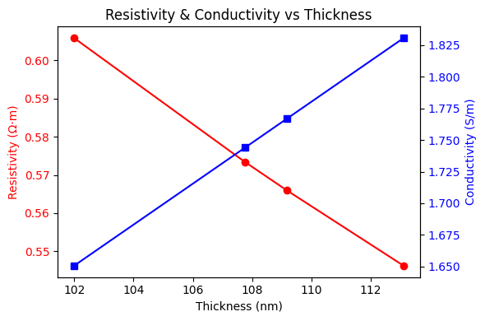
Graphical Abstract
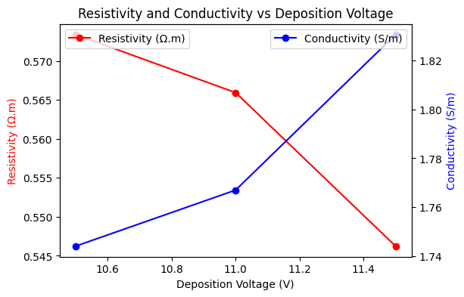

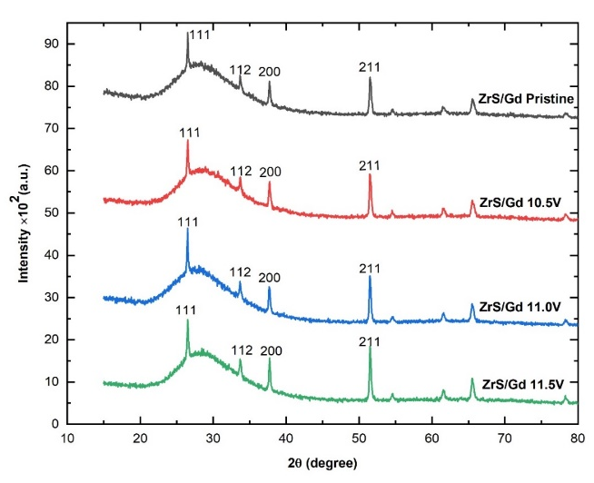
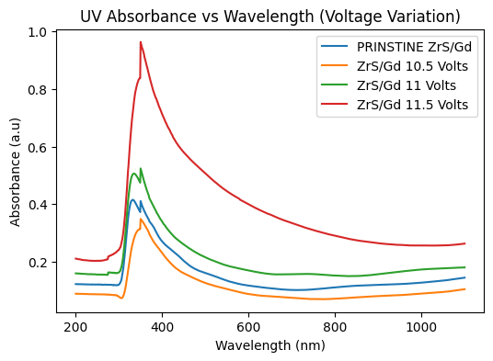

Research Highlights
- Deposition voltage strongly influenced the structural, optical, and electrical properties of the ZrS/Gd thin films.
- Enhanced UV absorbance (300–400 nm) was observed, with a maximum absorbance of 0.75 a.u at 11.5 V.
- Optical bandgap decreased from 3.62 eV to 3.21 eV with increasing deposition voltage, indicating improved photon absorption.
- Electrical conductivity improved significantly with Gd doping, reaching 1.89 S/m at 11.5 V, while resistivity decreased to 0.53 Ω·m.
- XRD analysis revealed enhanced crystallinity, increased crystallite size (178–200 nm), and reduced dislocation density at higher voltages.
Abstract
The zirconium sulphide (ZrS) metal has long been considered the most attractive material with fascinating physical, chemical, and optoelectronic properties. In this study, Gadolinium (Gd)-doped zirconium sulphide (ZrS/Gd) thin films were successfully deposited on fluorine-doped tin oxide (FTO) substrates using an electro-spray deposition technique at varying deposition voltages of 10.5 V, 11.0 V, and 11.5 V, aimed at optimizing their structural, optical, and electrical properties for photonic and optoelectronic applications. Comprehensive characterization of the films included structural, optical, electrical, and morphological analyses. X-ray Diffraction (XRD) was used to determine crystal structure and crystallite size, while Scanning Electron Microscopy (SEM) and Energy-Dispersive X-ray (EDX) verified surface morphology and elemental composition. Optical properties were obtained using a UV-Visible spectrophotometer, and electrical conductivity was measured with a four-point probe system. The result showed that UV–Vis spectroscopy enhanced absorbance in the UV region (300–400 nm), with 0.75 a.u absorbance at 11.5 V, while transmittance peaked at ~85% for the 11.5 V sample in the visible range. The calculated optical bandgap values decreased from 3.62 eV at 11.5 V to 3.21 eV at 10.5 V, indicating improved photon absorption with increased voltage. Optical conductivity reached a maximum of 0.73 S/m at 11.5 V, and refractive index peaked at 3.0 around 3.4 eV photon energy. Electrical analysis showed enhanced conductivity, increasing from 1.65 S/m in the undoped ZrS to 1.89 S/m at 11.5 V, while resistivity dropped from 0.61 Ω·m to 0.53 Ω·m. XRD analysis confirmed improved crystallinity and reduced dislocation density at higher voltages, with crystallite size ranging from 178 nm to 200 nm. SEM micrographs revealed uniform film deposition and nanoparticle agglomeration with no pinholes. These findings show that Gd doping and voltage-controlled deposition significantly enhance the optoelectronic properties of ZrS thin films, making them promising candidates for optoelectronics and photonics devices.
Keywords: Zirconium Sulphide, Gadolinium, Voltage, Absorbance, Energy Bandgap, Electrical Conductivity, Optoelectronics, Photonics, Nanoparticles

