Polarization-Controlled On-Axis Phase Matching in Extreme Four-wave Mixing
Nathan G. Drouillard¹ and TJ Hammond¹
¹Dept of Physics, University of Windsor, 401 Sunset Ave N9B 3P4, Windsor, ON Canada
Three photons interacting in a Kerr nonlinear medium to produce a fourth photon, called four-wave mixing (FWM), has found a wide range of applications such as parametric amplification and quantum optics. Because the gain scales with the pump intensity, ultrafast pump lasers enable FWM at extreme intensities, leading to enormous amplification. However, within scalar or co-polarized models of the Kerr nonlinearity, on-axis parametric gain is absent, and Kerr-driven instabilities rely on phase matching that favours off-axis modes through transverse momentum conservation. Non-collinear propagation reduces the pump-seed interaction length, placing an upper-bound on the achievable amplification.
Here we show that this picture changes when the seed field is orthogonally polarized with respect to the pump. We demonstrate that although orthogonal polarization reduces the effective gain, it allows on-axis phase matched parametric amplification in an otherwise isotropic Kerr medium, enabling significantly longer interaction lengths. In this regime, birefringence offers further control over the phase matched gain bandwidth.
The existence of on-axis gain has important consequences for the stability of the pump itself. In particular, it implies that the pump becomes unstable to on-axis perturbations in the orthogonal polarization, even in the absence of an external seed. At sufficiently high intensities and interaction lengths, this instability should manifest as on-axis spontaneous FWM or polarization-enabled modulation instability. These results identify polarization as a powerful control parameter for Kerr-instability dynamics and revise the standard understanding of phase matching in extreme four-wave mixing.
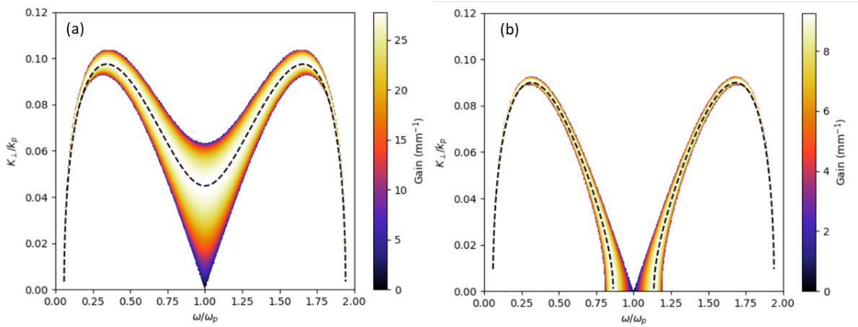
Figure 1: Transverse momentum and frequency dependent gain profile in FWM. (a) Co-polarized case only satisfies off-axis phase matching (dashed line). (b) Orthogonal polarization allows for intensity-dependent on-axis ($K_{⊥}=0)$ phase matching.

