Optimising a non-invasive viscosity measurement with portable NMR
2026 CAP Congress – Abstract Submission
Vincent Belzile, Igor Mastikhin
University of New Brunswick
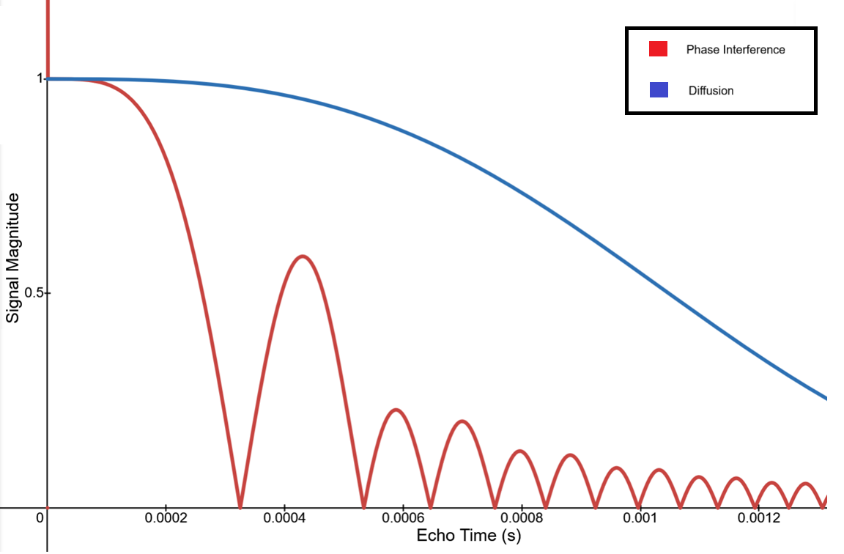
Fluid viscosity is typically measured using invasive techniques that involve the handling and probing of the fluid. This becomes an issue if the fluid needs to remain sealed due to hazardous properties or sensitivity to shear stress, like biopolymer formulations. To remedy this, a completely non-invasive measurement of the viscosity would be ideal. Magnetic Resonance Imaging (MRI) is an effective method that has been used extensively for rheological measurements. It also has the advantage of being able to gather information through opaque boundaries, opening the possibility of completely non-invasive measurements. In the presence of a magnetic field gradient, the measurement becomes sensitive to motion. Variations in the velocity of the fluid create phase interference, which directly modulates the magnitude of the gathered signal. In this work, the spin-up transition time of a rotating fluid cylinder is evaluated using phase interference and used to estimate the viscosity of the fluid. Depending on the strength of the magnetic field gradient, the contribution of both diffusion and phase interference will vary. To minimize the effects of diffusion, simulations were made to estimate the ideal experimental parameters.
Figure 1: Simulation of NMR echo signal magnitude against echo time for a 10-mm diameter cylinder with a rotation rate of 6.5 rad/s and a magnetic gradient strength of 250 G/cm: phase interference-induced (Red) and diffusion-induced attenuation (Blue).
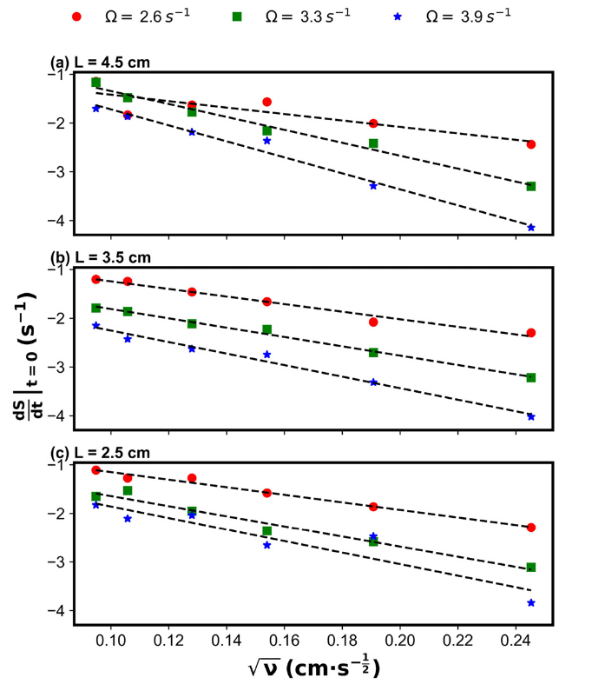
A previous implementation of this measurement done with a portable/handheld NMR device demonstrated a dependence of the transition time on viscosity, but it had a limited sensitivity in resolving shorter transition times. By using a stronger magnetic field gradient and a modified acquisition procedure, the sensitivity to motion can be greatly increased. Other magnetic field gradient orientations could also be used to evaluate different spin-up interactions in the fluid.
Figure 2: Plot of the results from previous implementation of the non-invasive measurement. Source: W. Selby, V. Belzile, J. Marshall, I. Mastikhin; Completely noninvasive viscosity characterization using a portable magnetic resonance sensor. Physics of Fluids 1 July 2025; 37 (7): 073119. https://doi.org/10.1063/5.0270641

