Attendance report
The Instituto Galego de Física de Altas Enerxías (IGFAE)
Reports that
xxx xxx
has given a talk the Solenoidal Spectrometer Workshop 2025, held in Santiago de Compostela from 9 to 12 December, 2025
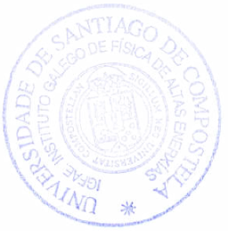
Signed,

Francesc Yassid Ayyad Limonge
Cristina Cabo Landeira
On behalf on the Local Organising Committee

Santiago de Compostela, 17/12/2025

