Abstract ID: {to be filled by the organizers}

Momentum-Resolved Spin Splitting in 3D Altermagnets: Interplay of Ferromagnetic and Antiferromagnetic orders

Primary author: Rotish Sarkar¹
Co-author: Dr. Nimisha Raghuvanshi*¹
Presenter: Rotish Sarkar
Track Classification: Track 03

¹ Department of Engineering Sciences, Assam Energy Institute (RGIPT), Assam

*Corresponding Author: rotishs23ea@rgipt.ac.in

Abstract: This work synthesizes theoretical advances in Altermagnetism, a third type of collinear magnetism Similar to standard Antiferromagnetic (zero net magnetisation) and Ferromagnetic (spin splitting in band structure), aming to validate Altermagnetic band splitting in a real material and to propose a new correlation-driven mechanism. Chromium antimonide (CrSb) is demonstrated as a metallic altermagnet, exhibiting large, momentum-dependent spin splitting without net magnetization in the band structure. We developed a minimal two–orbital tight-binding model for the NiAs–type hexagonal lattice of CrSb. The theoretical model is a two-band Hubbard-like Hamiltonian solved at mean-field level , orbitals on a hexagonal lattice incorporating intra- and inter-orbital hopping up to third-nearest neighbors on the $d_{xy}$ and $d_{x^{2}-y^{2}}$ orbitals. By fitting hopping parameters ( $t_{1}=t_{2}=1.75$, $t_{3}=t_{4}=0.85$, $r=-1.95$, $s=-0.65$, $s_{h}=-0.05$ ) in energy units along the high-symmetry $M$–$Γ$–$M$ path. It is analysed for coexisting Neel antiferromagnetic (AFM) and staggered orbital order (OO), the model reproduces the nonmagnetic band dispersion neglecting the interaction terms i.e. AFM and OO interaction and quantitatively captures key features of angle-resolved photoemission spectroscopy (ARPES) data near the Fermi level. Direct ARPES measurements reveal an anisotropic band splitting of approximately 0.6 eV linked to the $d_{x^{2}-y^{2}}$ orbital character, confirming exchange-induced altermagnetic order above 700 K. Our results establish CrSb’s simple orbital framework as an ideal platform for theoretical studies and practical spintronic applications, where field-free, spin-polarized transport and anomalous Hall phenomena arise from intrinsic momentum-space spin polarization
The orbital-order and Antiferromagnetic-order model demonstrates a new design principle: electronic correlations and orbital ordering and antiferromagnetic ordering can induce altermagnetism in lattices without considering relativistic spin-splitting. This expands the search space for altermagnets to correlated oxides and other systems. In both cases, the large momentum-dependent spin polarization and associated transverse spin currents point toward device concepts combining ferromagnet-like spin polarization with antiferromagnetic robustness. These advances inform material design strategies (e.g. engineering Cr–Sb hopping paths or orbital occupations) and point to novel spintronic applications leveraging altermagnetism.
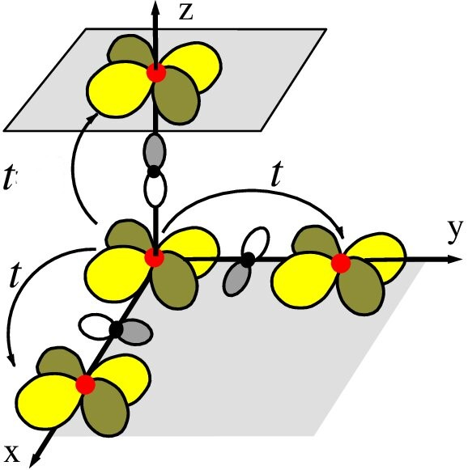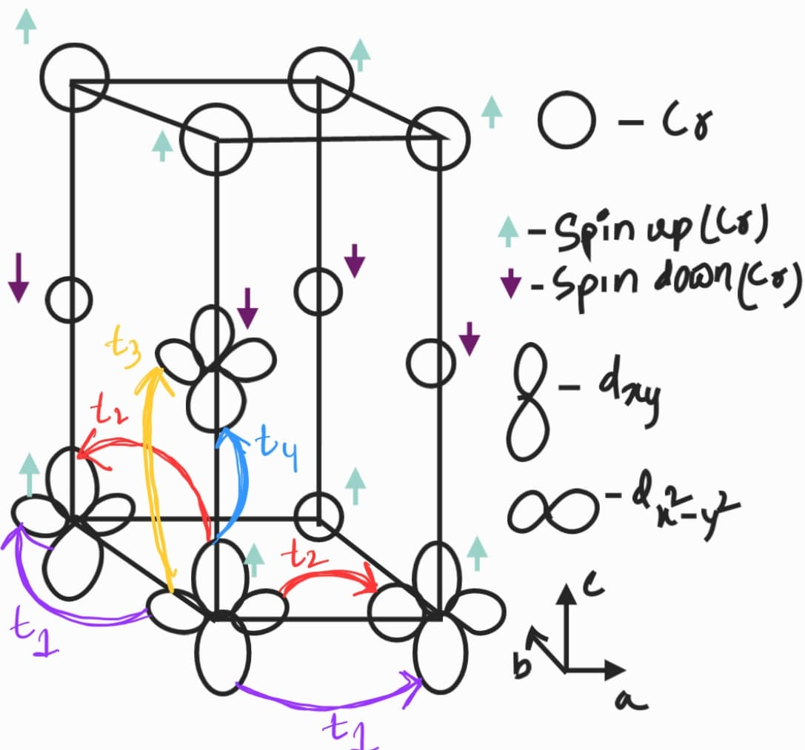

Fig: Hopping mechanism takes place in the CrSb crystal structure

References:
- Direct observation of altermagnetic band splitting in CrSb thin filmsSonka Reimers, Nature Communications volume 15, Article number: 2116 (2024)
- Observation of giant band splitting in altermagnetic MnTe T. Osumi, arXiv:2308.10117v2 10 Feb 2024
- Discovery of a metallic room-temperature d-wave altermagnet KV2Se2O Bei Jiang arXiv:2408.00320
- Electrical transport phenomena in MnTe, an antiferromagnetic semiconductor Wasscher, J. D. (1969) DOI: 10.6100/IR43336
- Néel vector-dependent anomalous transport in altermagnetic metal CrSb Check for updates, Tianye Yu1, 10.1038/s41535-025-00766-3, May 2025
- UNUSUAL SYMMETRIES IN THE KUGEL-KHOMSKII HAMILTONIANA. B. Harris, August 2003 Physical Review Letters 91(8):087206
- Observation of Spin Splitting in Room-Temperature Metallic Antiferromagnet CrSb Meng Zeng, doi.org/10.1002/advs. 02406529, 20 September 2024
- Emerging Research Landscape of Altermagnetism Libor Šmejka, Phys. Rev. X 12, 040501,8 December, 2022
- Spontaneous Formation of Altermagnetism from Orbital Ordering Valentin Leeb, Phys. Rev. Lett. 132, 236701, 3 June, 2024
- esm2023-wunderlich-slides-2, Talks - Altermagnetism 2023 - Libor ŠMEJKAL, JGU

