Ultra Thin Polarization Insensitive Band-Pass Frequency Selective Surface For Ku Band Applications
Debasish Das*, Hirokjyoti Das, Nidhi S. Bhattarcharyya
Emails: dasdebasish278@gmail.com, hirokjyotidas245@gmail.com
A frequency selective surface (FSS) is a thin, repetitive surface designed to reflect, transmit or absorb electromagnetic fields based on the frequency of the incoming radiation and resonant frequency of the elements. By altering the electromagnetic waves that strikes them, the frequency produce dispersive transmitted and/or reflected attributes. The desired characteristics of FSS include a low profile, decreased periodicity, dual polarization, angular stability and ease of manufacturing. Unlike idealized FSS models, real-world designs incorporate factors such as material imperfections, fabrication tolerances, and environmental influences, which can affect performance and necessitate careful optimization. According to the filtering characteristics the FSS can be divided into four types: low pass, high pass, passband and band stop. In wireless communication, FSS are implemented to reduce electromagnetic interference (EMI) and enhance signal clarity by filtering certain frequency bands. They are also used in stealth technology and reducing RCS [1, 2].
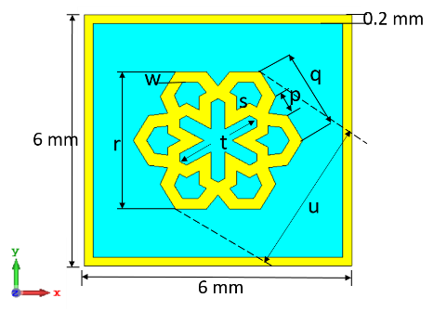
The objective is to develop a wideband FSS that operates at Ku band frequency range (12-18 GHz) for potential applications in satellite communication, radar, and stealth technologies. This paper presents the design and fabrication of a wideband band-pass FSS incorporating periodic structures based on square unit cell with interconnecting double hexagonal loop resonator at the center surrounded by a square ring resonator at the edges. The simulation process was conducted using CST software. FR4 was selected for substrate and copper was used as conductive layer to make patterns on the substrate. The dimension of the substrate is 6 mm×6 mm with a thickness of 0.4 mm. The thickness of the copper layer is 0.035 mm. The structure was optimized for minimal insertion loss in the passband and high rejection outside it. Simulation results demonstrated a clear band-pass response centered around 15.04 GHz with a bandwidth of 5.26 GHz. The designed unit cell was then simulated for a FSS of 22×22 unit cells and fabricated. The simulated and experimented results are found to be comparable.
99a)a0
(b) Side view of simulated unit cell
(a) Front view of simulated unit cell
References
[1] Munk, B. A. (2005). Frequency selective surfaces: theory and design. John Wiley & Sons.
[2] Anwar, R. S., Mao, L., & Ning, H. (2018). Frequency selective surfaces: A review. Applied Sciences, 8(9), 1689.
[3] Shukor, M. M., Aziz, M. A., Ahmad, B. H., Suaidi, M. K., Johar, M. F., Othman, M. A., ... & Malek, M. A. (2014, May). Characteristic impedance modelling of circular loop and square loop frequency selective surface (FSS) on hybrid material. In 2014 International Symposium on Technology Management and Emerging Technologies (pp. 486-491). IEEE.
[4] Nafis, N. B. M., Rahim, M. K. A., & Himdi, M. (2022, October). Bandwidth Enhancement by Interconnecting Double Hexagonal Loops FSS. In 2022 International Symposium on Antennas and Propagation (ISAP) (pp. 463-464). IEEE.
[5] Murakonda, S., Carishma, L., & Pradhan, N. C. (2025, June). Compact Single Resonator Dual-Bandstop FSS Filter with Wider Angular Stability for S, and X-Bands. In 2025 Third International Conference on Microwave, Antenna and Communication (MAC) (pp. 1-6). IEEE.

